The more that you read, the more things you will know.
The more that you learn, the more places you’ll go.
- Dr. Seuss

Friday 27th January 2023
Dear Parent or Guardian,

We are running a Read for Good Readathon as part of our support of Children’s Mental Health Week. The Readathon event begins on Monday 30th January and ends on Friday 10th February.

It’s been proven that children who read for pleasure are more likely to be successful and happy throughout their lives (OECD), therefore, we would love for our Palace wood children to join in.

The charity Read for Good encourages children to read through its unique motivational approach inspiring reluctant readers to give reading a go, and keen readers to read more widely. Pupils can choose whatever they want to read - from comics to classics and audio books to blogs - they are not being assessed, it’s all about reading for fun. And, they are motivated to read because the money they raise in sponsorship helps to provide provide a regular supply of brand new books and a resident storyteller to every major children’s hospital in the UK.

Teachers, parents and pupils tell us that the freedom to choose what to read, combined with the knowledge that they are directly helping children in hospital compels pupils to get involved.

All you have to do is:

- Take a look at what your child plans to read, or help them complete their list of books to read. Remember they can read whatever they want: books, e-books, poetry, comics – anything goes! Sharing books is fine too (in fact recommended!) as well as listening to audio books.

- Help your child find sponsors among family and friends. The easiest way to sponsor a child is at https://readathon.secure.force.com/sponsor (which family and friends can use too) or return the sponsor card with a cheque(s) or cash sent to school by Friday 10th February.

Please support your child’s sponsored read as much as you can. They’ll be helping kids in hospitals get books, as well as helping themselves. And our school receives free books worth 20% of our grand sponsorship total – so there really is something in it for everyone. We shall be sending children home with their sponsor cards today (Friday 27th January) ready for them to start using from Monday 30th January so do check their school bags.

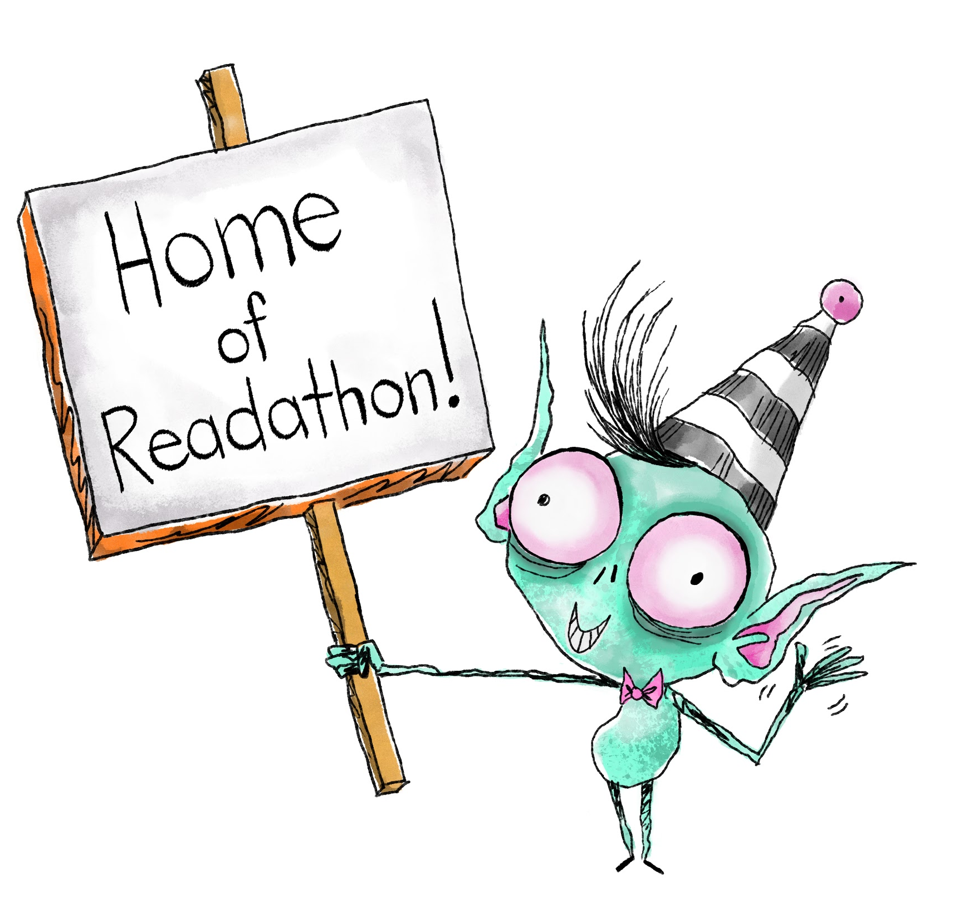
For more information, check out your child’s sponsorship card and visit www.readforgood.org.

Kind regards,

Mrs Childs,
English Leader and Senior Mental Health Lead

Thank you for your support – helping your child to keep reading, raising money
and being amazing!!

